
IEC TC 111 International Standards
IEC 62321

IEC TC 111
IEC Technical Committee (TC) 111: Environmental standardization for electrical and electronic products and systems, prepares basic and horizontal IEC International Standards, guidelines and Technical Reports, mainly for the electrical and electronic (EE) industry sector. However these standards may also be used outside the EE sector.
TC 111 regularly monitors national and regional standardization and regulatory activities with a view of becoming the focal point in that area.

IEC 62321 family of Standards
IEC 62321 provides appropriate test methods to verify certain substances in the materials and parts of the products for suppliers and manufacturers in the supply chain. There are many environmental regulations requiring for a limit of content of hazardous substances, and in order to have a fair and comparable declaration from suppliers, it is in the interest of manufacturers to have a common method of measurement of these substances.
IEC 62321 “Determination of certain substances in electrotechnical products”
- Part 1: Introduction and overview (2013-05-17)
- Part 2: Disassembly, disjunction and mechanical sample preparation (2013-06-25)
- Part 3-1: Screening - Lead, mercury, cadmium, total chromium and total bromine using X-ray fluorescence spectrometry (2013-06-19)
- Part 3-2: Screening - Total bromine in polymers and electronics by Combustion - Ion Chromatography (2013-06-19)
- Part 4: Mercury in polymers, metals and electronics by CV-AAS, CV-AFS, ICP-OES and ICP-MS (2013-06-19)
- Part 5: Cadmium, lead and chromium in polymers and electronics and cadmium and lead in metals by AAS, AFS, ICP-OES and ICP-MS (2013-06-25)
- Part 6: Polybrominated biphenyls and polybrominated diphenyl ethers in polymers by gas chromatography–mass spectrometry (GC-MS) (2015-06-05)
- Part 7-1: Presence of hexavalent chromium (Cr(VI)) in colourless and coloured corrosion-protected coatings on metals by the colorimetric method” (2015-09-16)
- Part 7-2: Determination of hexavalent chromium (Cr(VI)) in polymers and electronics by the colorimetric method (2017-03-28)
- Part 8: Part 8: Phthalates in polymers by Gas Chromatography-Mass Spectrometry (GCMS), Pyrolysis/Thermal Desorption-Gas Chromatography-Mass Spectrometry (Py/TD-GC-MS) (2018-03-28)
Developing New IEC 62321 family of Standards (FDIS stage)
- Part 9: Hexabromocyclododecane in polymers by high pressure liquid chromatography-mass spectrometry (LC-MS)
- Part 10: Polycyclic aromatic hydrocarbons (PAHs) in polymers and electronics by gas chromatography-mass spectrometry (GC-MS)
Beyond these IEC 62321 family of Standards, WG3 provides to date
- 9 International Interlaboratory Study (IIS) Reports
- 1 International Standard Amendment: IEC 62321-4:2013/AMD1:2017
- 1 Technical Report (TR) : IEC TR 62936 – Substance Selection Guide: 2015

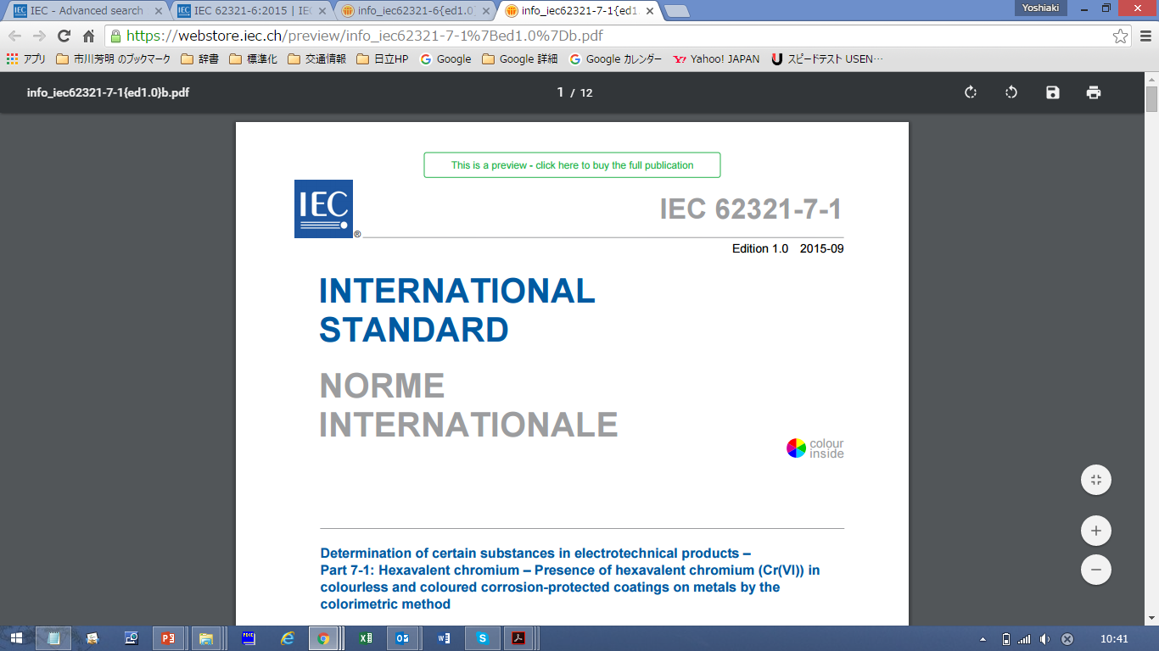
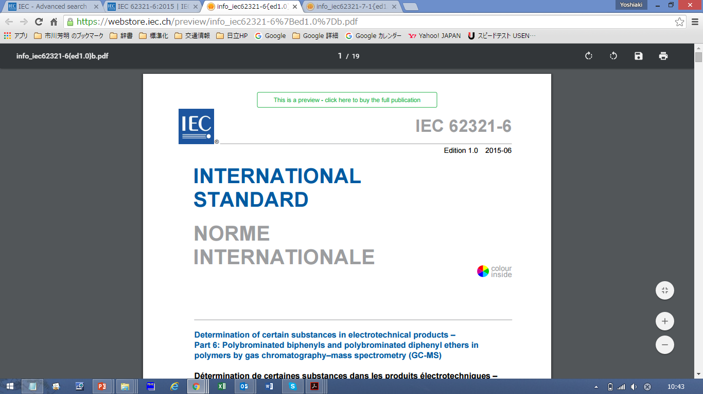
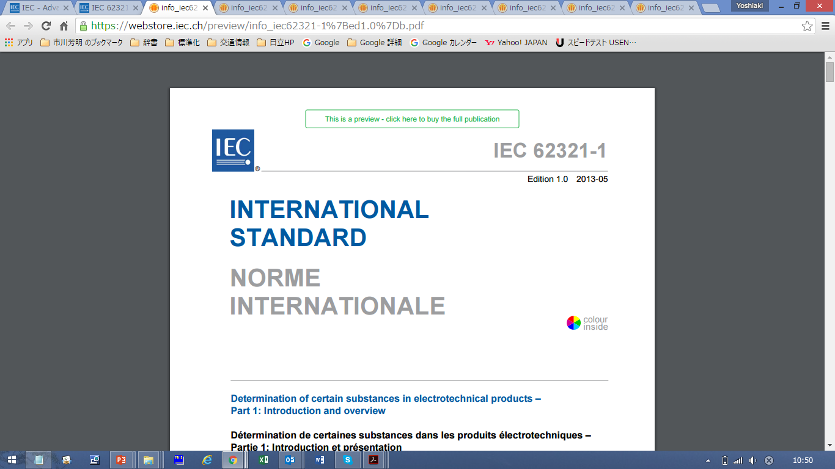
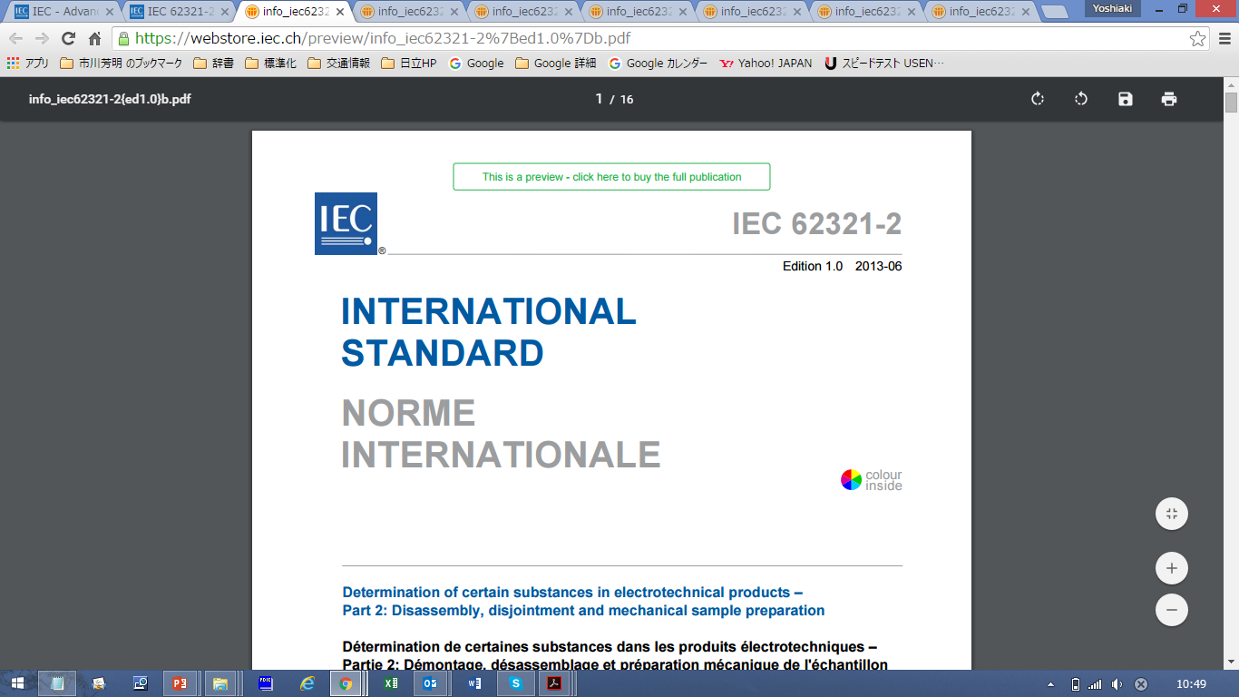
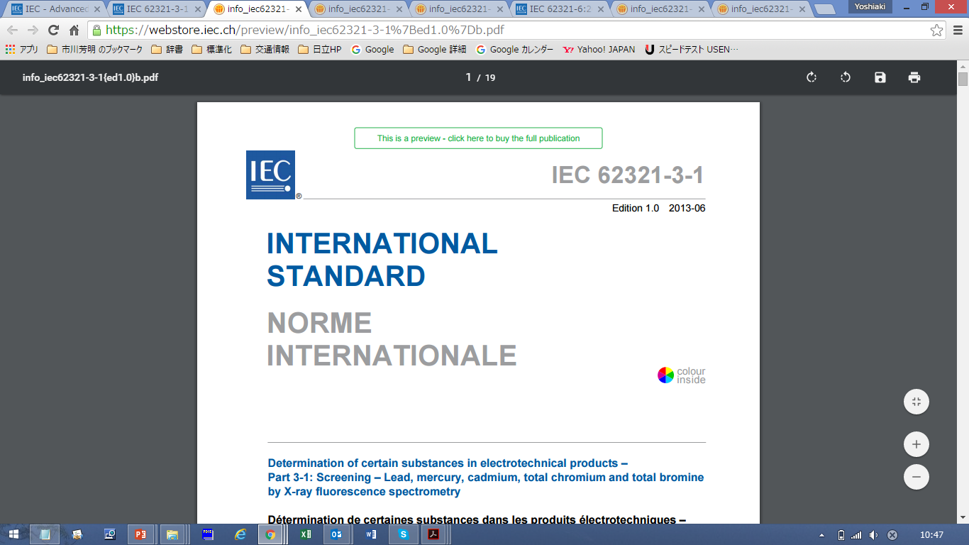
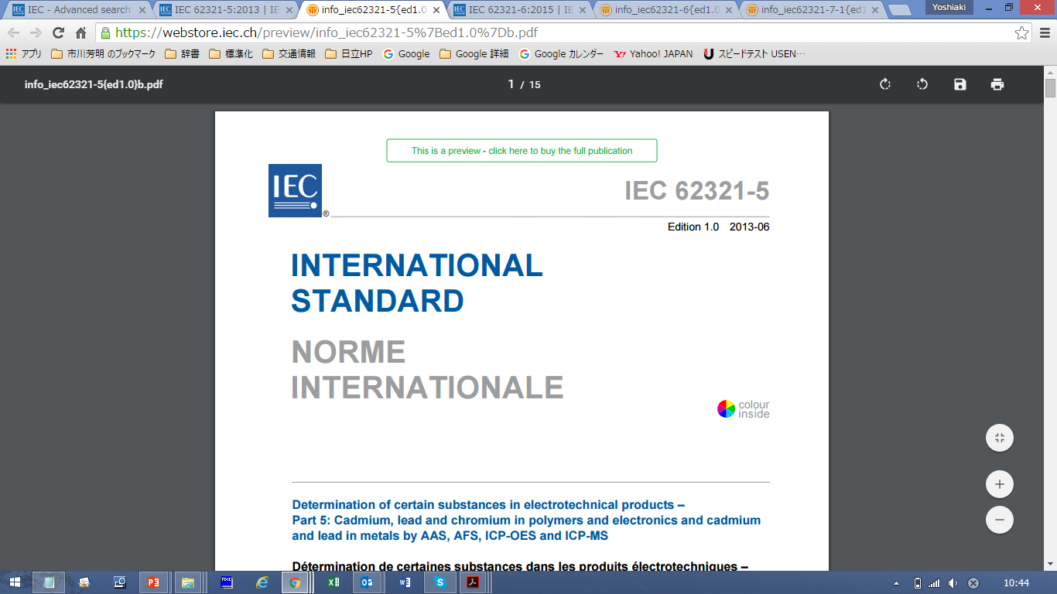
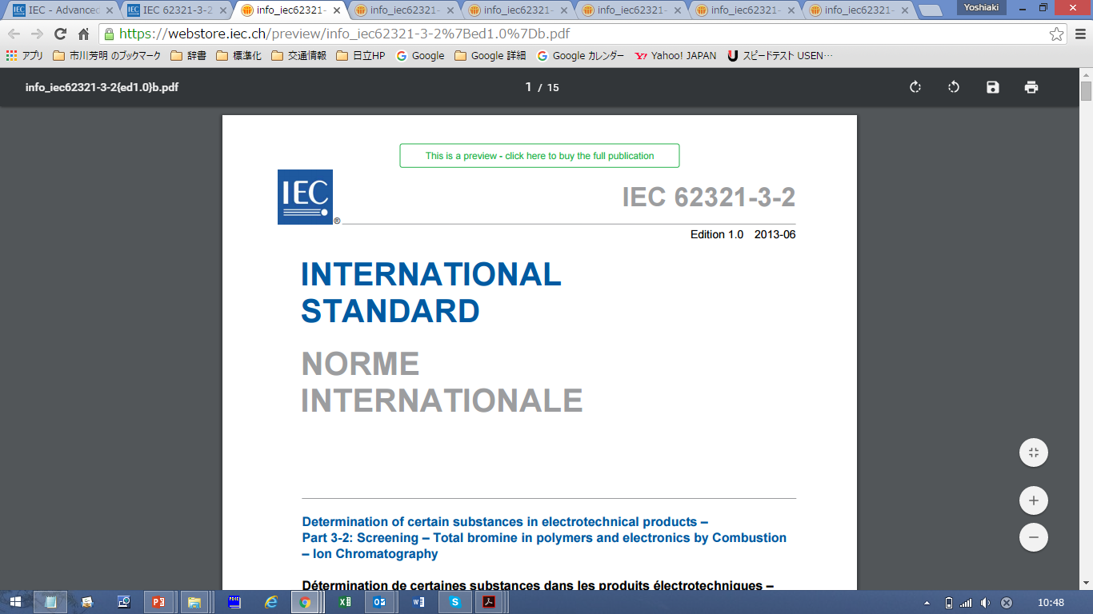
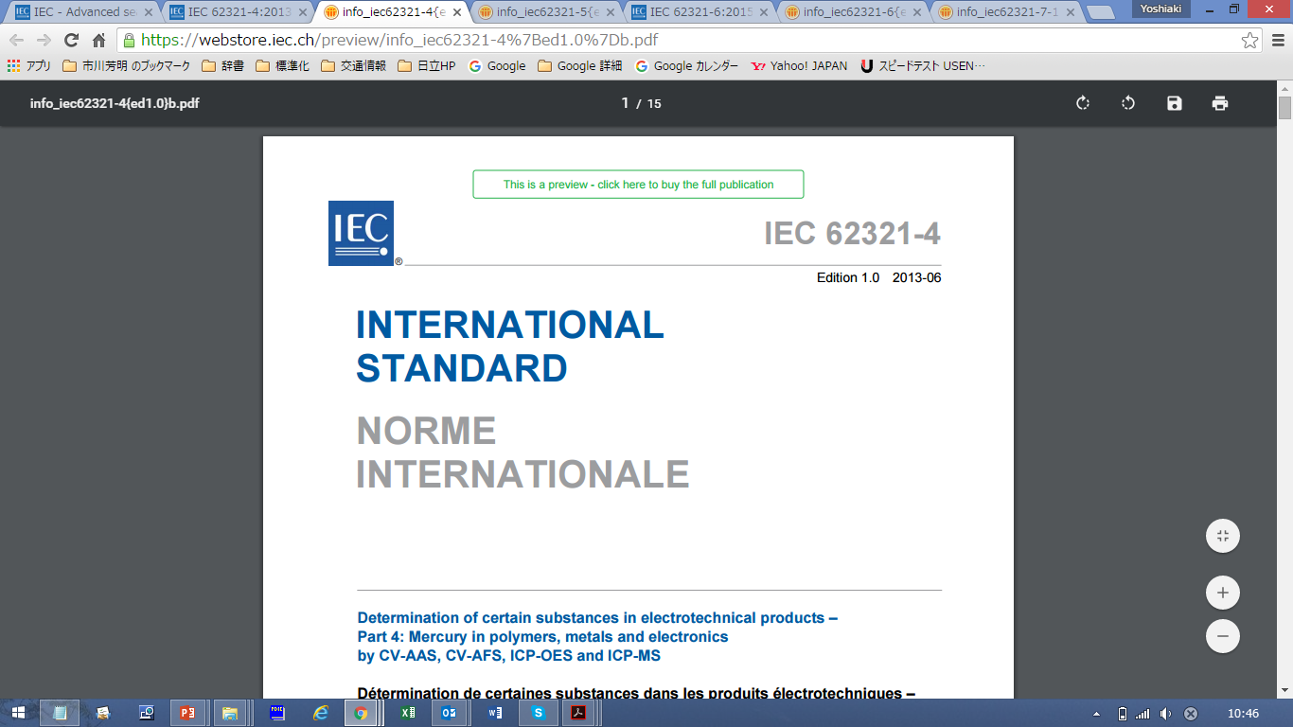

History of IEC 62321
The widespread use of electrotechnical products has drawn increased attention to their impact on the environment. In many countries this has resulted in the adaptation of regulations affecting wastes, substances and energy use of electrotechnical products.
The use of certain substances (e.g. lead (Pb), cadmium (Cd), polybrominated diphenyl ethers (PBDEs), phthalates, etc.) in electrotechnical products, is a source of concern in current and proposed regional legislation.
IEC 62321 initially started its activities with the aim of developing the international standards of test methods for the restricted substances in RoHS directive (2002/95/EU) since May 2004. IEC 62321 (Single Document) published in 2008.
According to the range of environmental issues has increased, the many environmental regulations are enacting around the world such as RoHS, REACH, WEEE and so forth. In response to these trends, IEC 62321 expanded the target substances and divided into IEC 62321 family of Standards considering the improvement of maintainability and user benefits.
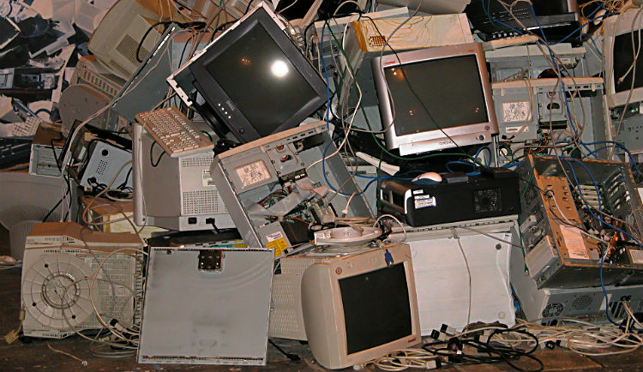
Purpose of IEC 62321
The purpose of the IEC 62321 family of Standards is to provide test methods that will allow the electrotechnical industry to determine the levels of certain substances of concern in Inter-Laboratory Study (IIS). So far, laboratories from all over the world have participated in IIS and contributed to the establishment of IEC 62321 family of Standards.
Summary of standard requirements
IEC 62321 family of Standards specify the appropriate sampling and test methods to the electrical and electronics industry and its suppliers:
1. How to collect samples
IEC 62321 Part 2 provides strategies of sampling along with the mechanical preparation of samples from electrotechnical products. These samples can be used for analytical testing to determine the levels of certain substances as described in the test methods in other parts of IEC 62321. Restrictions for substances will vary between geographic regions and may be updated on a regular basis. This document describes a generic process for obtaining and preparing samples prior to the determination of any substance which are under concern.
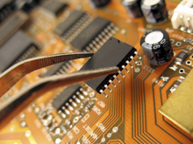
2. How to screen the substances
IEC 62321 Part 3 series provide the analyst a convenient approach to evaluate for the presence or quantity of certain substance(s) in samples as screening methods. Screening may employ qualitative or semi-quantitative methods. Depending on the screening results however, additional analysis methods may need to be employed to definitively verify the presence or quantity of certain substances. These definitive analysis methods are referred to as verification methods.

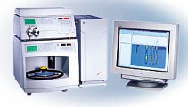

3. How to evaluate by the verification methods
IEC 62321 Part 4 and the later chapters provide the verification test procedures. The verification test procedures are often employed to confirm the presence or quantity of certain substances of concern after a screening procedure has been performed (e.g. to determine if the source of “screened” bromine is from a bromine compound of concern). Alternatively, verification test procedures can be performed independent of a screening procedure.
Verification procedures are typically performed after mechanical and chemical sample preparation using a variety of test methods tailored to the substances of concern and the sample, which can be a polymer, a metal or electronics.



Associated databases/tools
IEC 62474 (Material Declaration for Products of and for the Electrotechnical Industry) DB
http://std.iec.ch/iec62474

Laws/regulations quoting IEC 62321
Many countries are quoting IEC 62321 in their laws, and many countries translate IEC 62321 into the national standards. IEC 62321 becomes a globally recognized test methods for the certain substances in electrotechnical products.
Quoting by the Main Laws/regulations
・EU RoHS Mandate M/499 (EN 50581)
・Thailand RoHS（TIS 2368-2551)

・Vietnam RoHS (30/2011/TT-BCT)
・Canadian Product Mercury Regulation (Vol.148. No.24, 2014)
・Eurasia Customs Union RoHS (ТR ЕАЭС 037/2016)
・UAE RoHS (Cabinet Decision No. 10/2017)
・Korea RoHS & ELV (Act on Resource Circulation of Electrical and Electronic Equipment and Vehicles)

Quoting by the National Standard
・DIN EN 62321
・BS EN 62321
・China GB/T26125-2011
・Korea KS C IEC 62321
・India BIS ET-43 (6628-6633)
・J-MOSS (JIS C0950)
・GSO IEC 62321

Benefits of IEC 62321
Governments/regulators
To assist to monitor as the market surveillance for RoHS, REACH, or the regional regulations.
National standards bodies
To comply with the WTO/TBT agreement by referring the IEC 62321 to their national standards.
Manufacturers
To support to prepare for their technical documentation for product certification and compliance assessment according to IEC 63000.
Suppliers
To harmonize requirements across the supply chain and to improve economic efficiencies using IEC 62321 an International Standard for the testing methods.
Investors
To support to evaluate the environmentally soundness of the investee.
Testing organizations
To support their conformity assessment based on IEC 62321.
To be certified by ISO/IEC 17025 according to IEC 62321.
IT tool providers
To support their data base aligning with IEC 62474 (Materials Declaration)
Other non-governmental organizations
To help the environmental conscious purchasing.
Future plan of IEC 62321
TC 111/WG 3 established IEC 62321 family of Standards for electrotechnical industry to be used by labs globally for manufacturers, suppliers, OEMs, NGOs, governments, etc. However, these test methods may also be used outside the EE sector according to the technology innovation. Moreover, the testing methods from the viewpoint of materials efficiency has become an important topic growing interested in the Circular Economy.
In response to these expectations, WG 3 started collaboration with ISO/TC 61/SC 5 (Plastics – Physical-chemical properties) since 2019 to make the dual logo standards. TC 111/WG 3 will initiate test methods needed by industry ahead of regulation effective dates.
TC 111/WG 3 needs more collaboration with the technical experts from other TCs inside/outside IEC, global laboratories, and national metrology institutes. Whoever are interested in WG 3 activity, we are very welcome. Please visit TC 111 web site;
https://dev-tc111.ieccloud.com/

